# Shell Script Assignment

**Mandatory:**

1. Create a script named “myscript” in current directory to do the following.
2. display “hello user”

Ans) echo $hello user

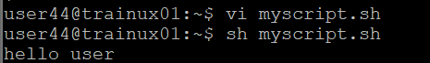

1. list files in current directory

Ans) ls

1. name of logged in use

Ans) whoami



1. date

Ans) 

1. Add execute permission and Run the script from
2. current directory

Ans) chmod 0755 myscript.sh



1. Create a subdirectory named “test”

Ans) mkdir test

